Amazon simple queue service(amazon SQS)

It is a fully managed message queuing service that allows you to decouple and scale microservices,distributed systems,and serverless applications.It acts as a reliable intermediary,storing messages asynchronously until application components are ready to retrieve and process them.

Amazon Simple Queue Service(Amazon SQS)lets you send,store,and receive messages between software components at any volume,without losing messages or requiring other services to be available

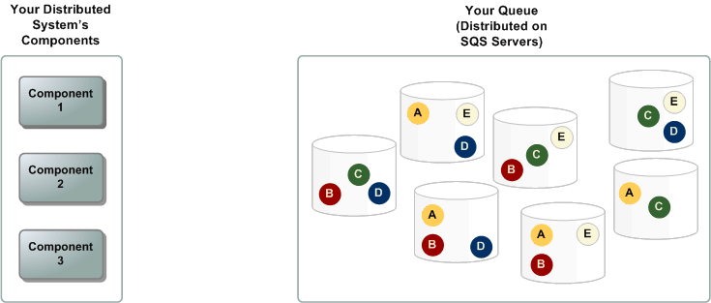

There are two types of SQS
- Standard queue
- Fifo(first in first out)queue
Feature | Standard Queue(Default) | FIFO Queue(.fifo suffix)
Ordering | Best-effort ordering. | Strict First-In-First-Out ordering.
Delivery | At-least-once delivery(duplicates possible). | Exactly-once processing  (no duplicates).
Throughput | Unlimited transactions per second(TPS). | High throughput mode supports up to 6,000–60,000 TPS.
Common Use | Decoupling high-volume transaction logs. | Banking transactions or e-commerce orders

SQS utilizes a pay-as-you-go pricing model with zero upfront or provisioning fees:
- Free Tier:The first 1 million requests each month are completely free.
- Standard Rates:Requests beyond the free tier cost roughly$0.40 per million for standard queues and$0.50 per million for FIFO queues.
- Data Egress:Data transfers within the same AWS Region to Lambda or EC2 are completely free

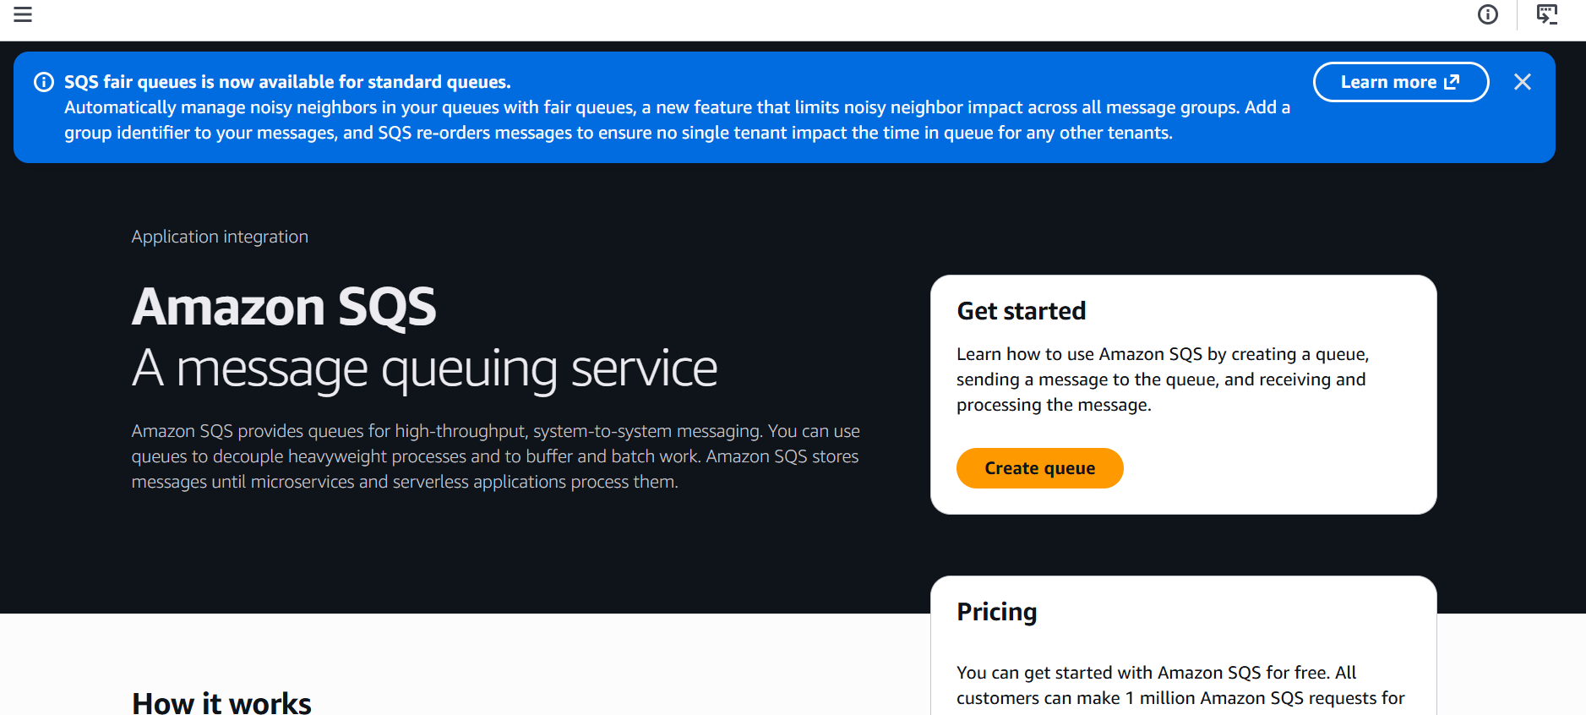

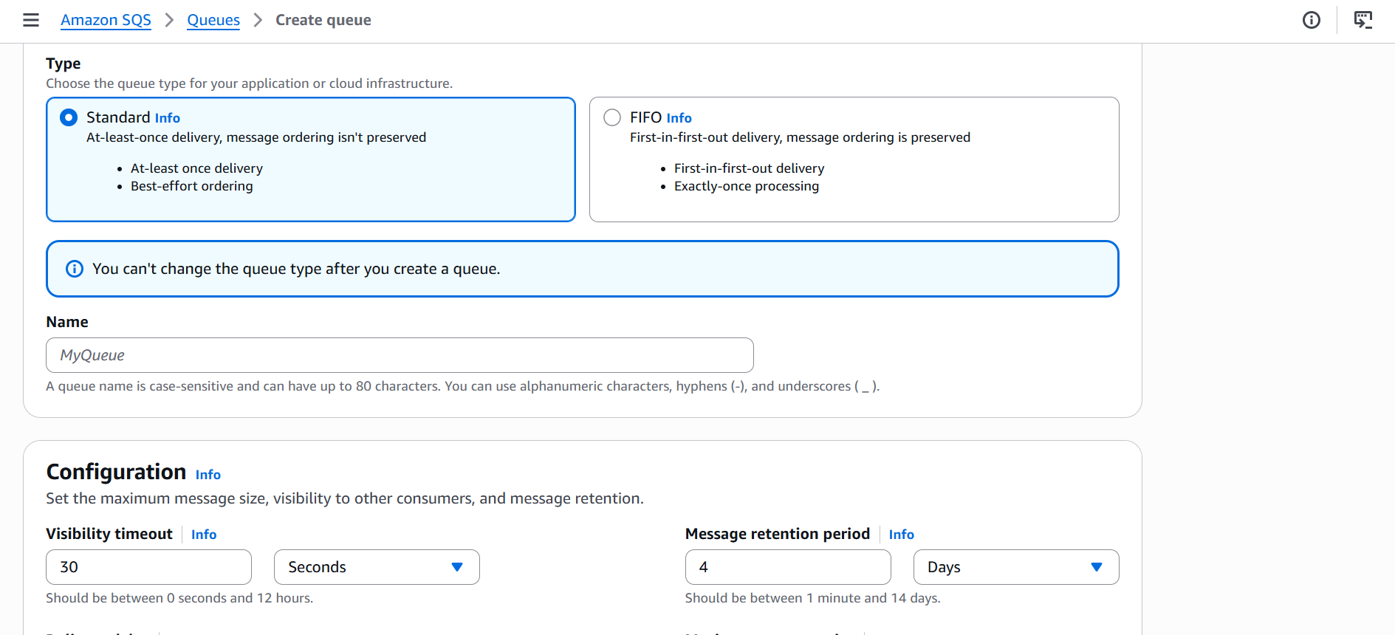

We can select any queue based upon our requirement
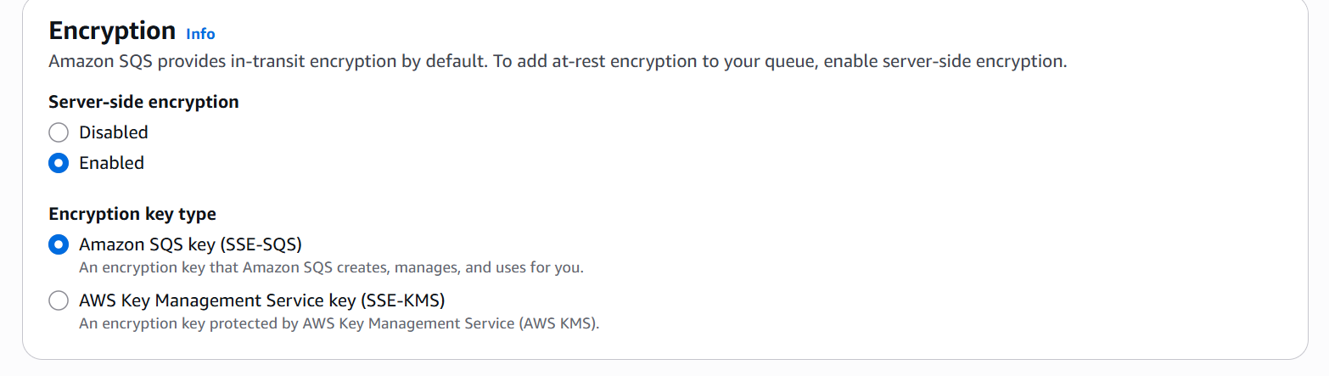

We can encrypt with two keys
We can use either sqs key or sse-kms

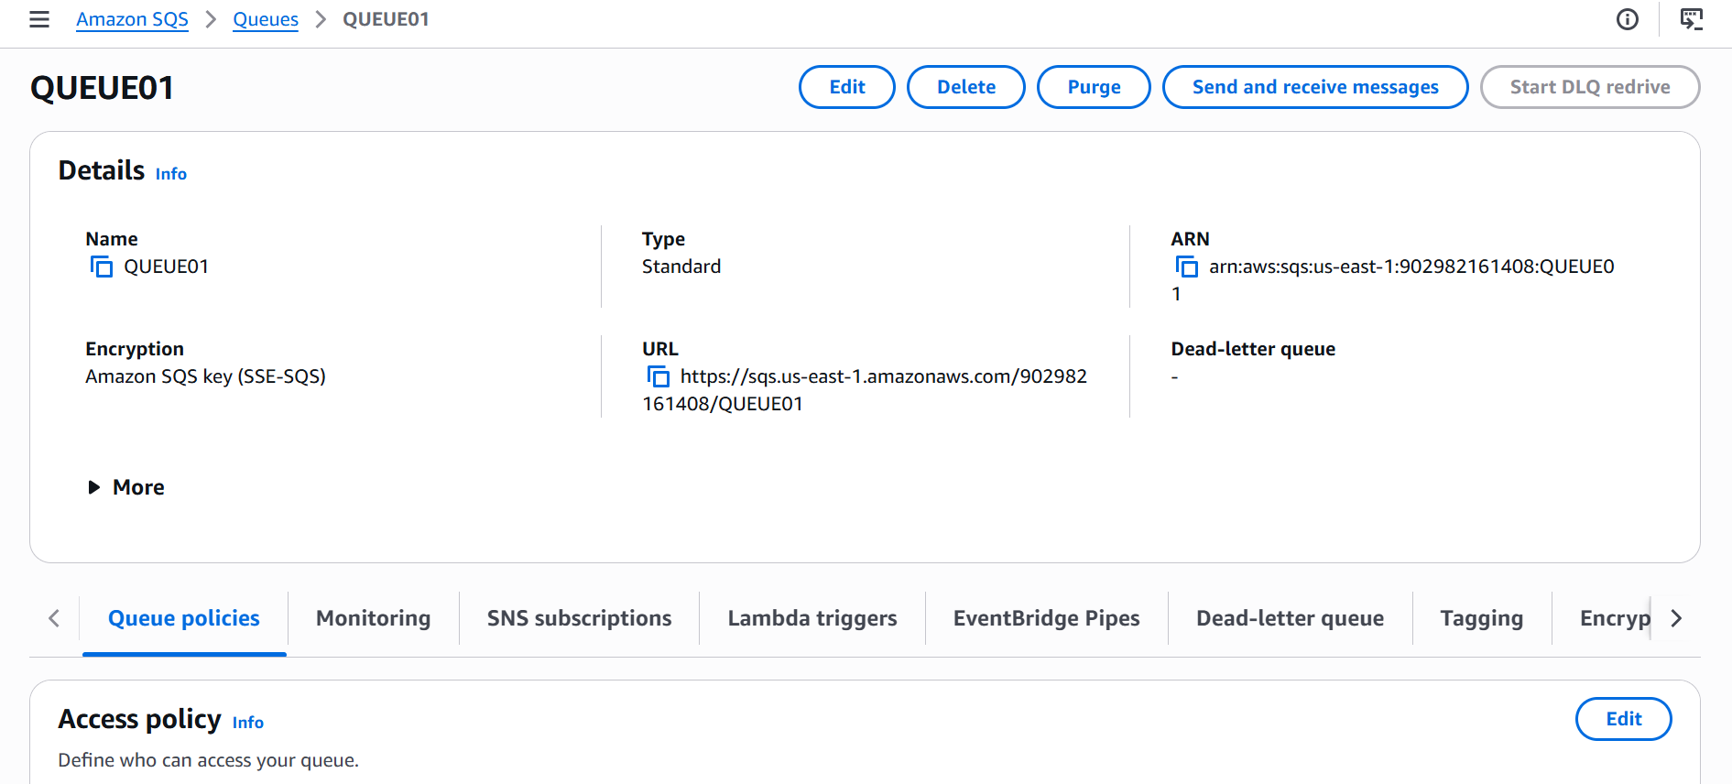

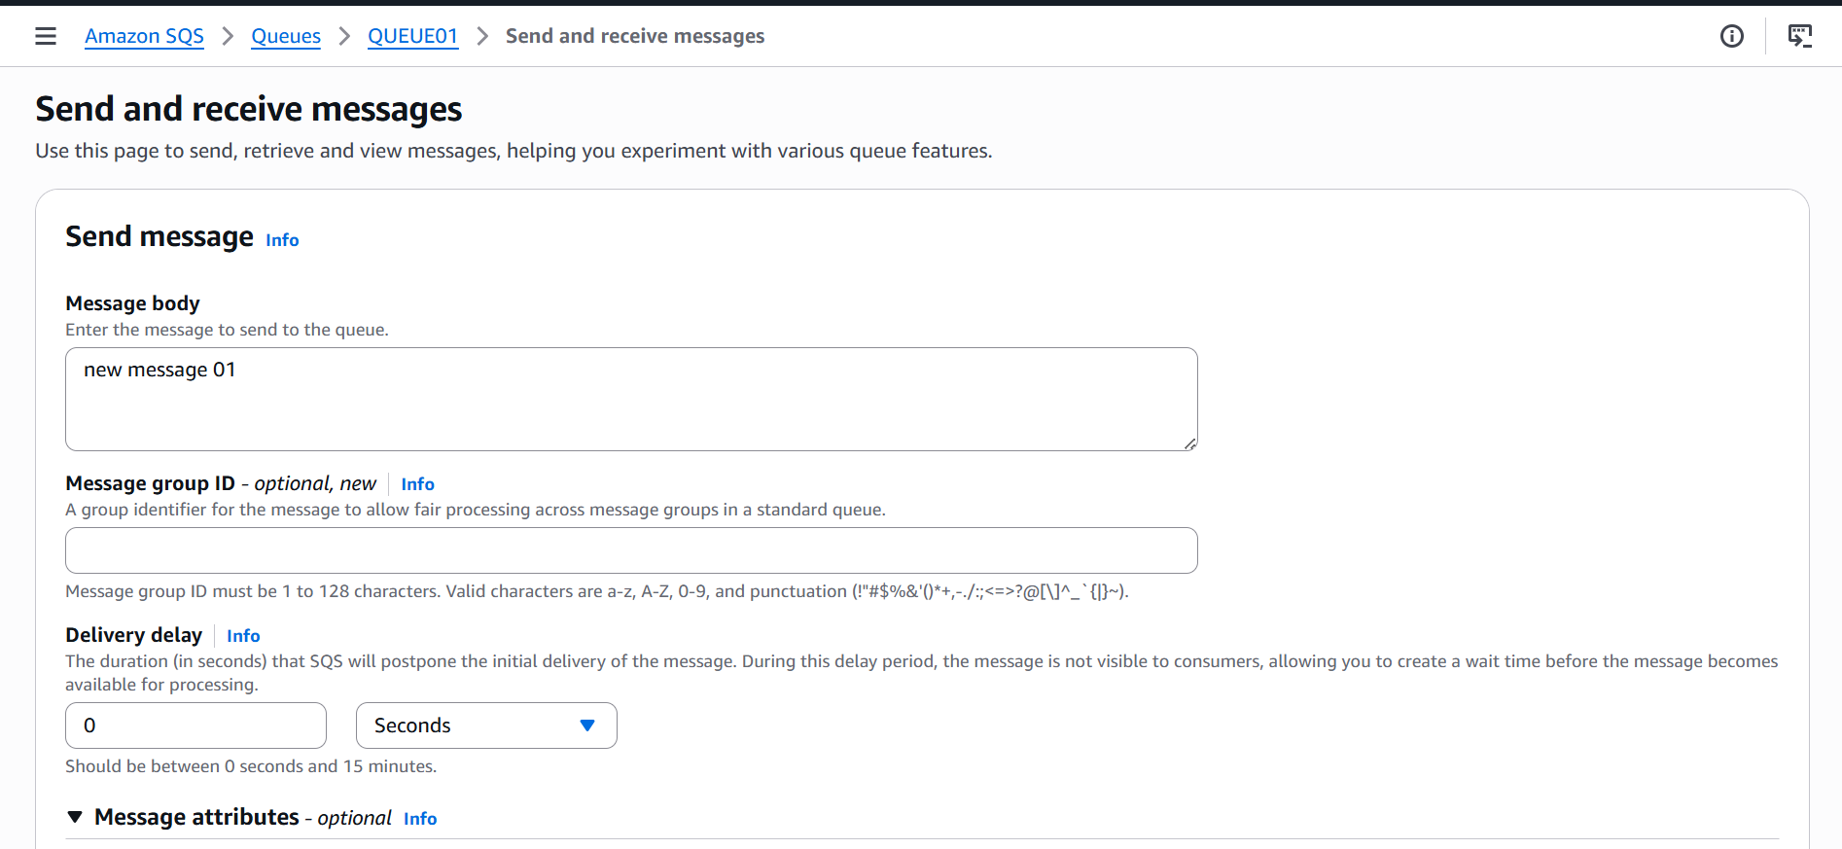

I can send a new message and it can also be used to communicate b/w two services

I have sent a sample message and it will be received in poll messages

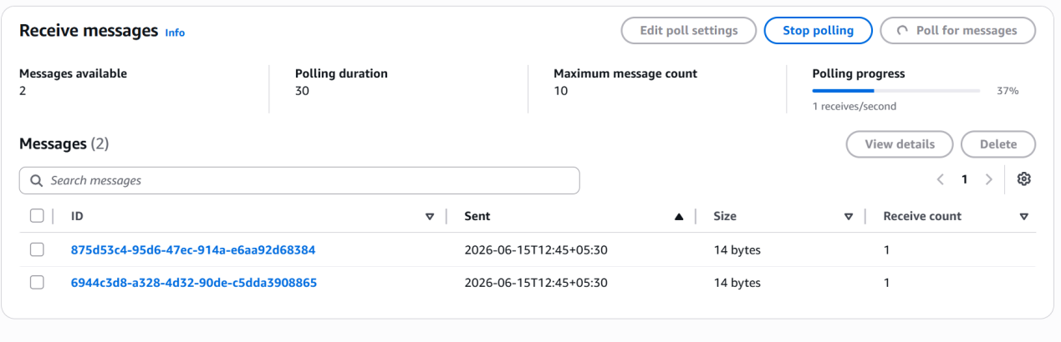

I can add the sqs to lambda for not having any manual interaction

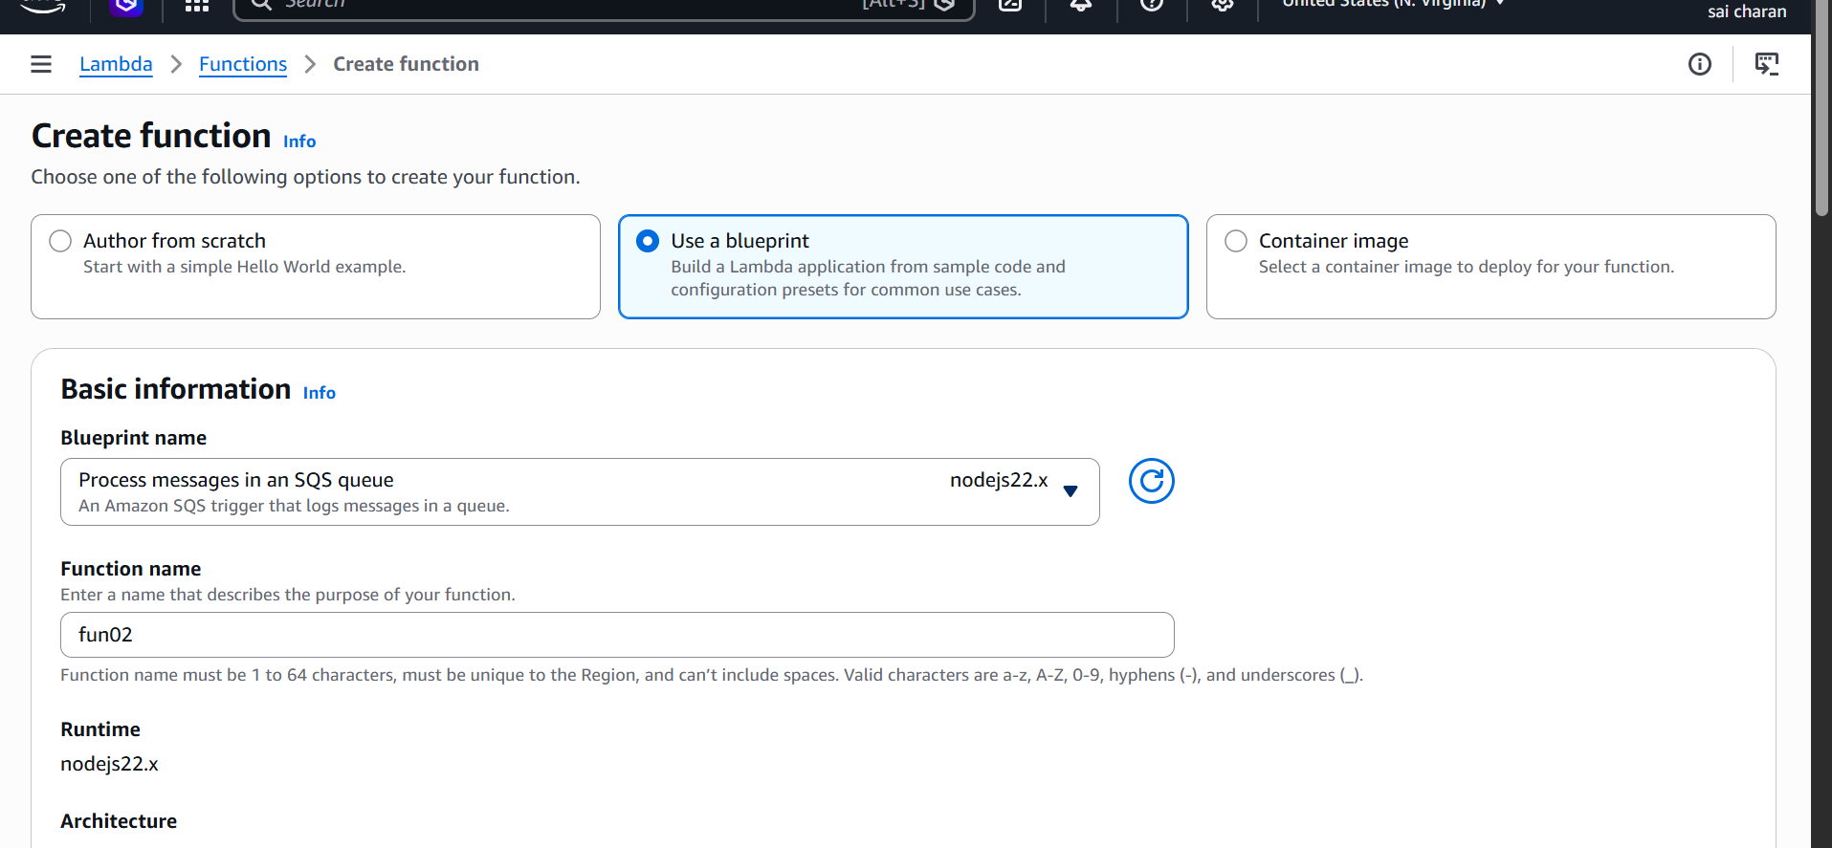

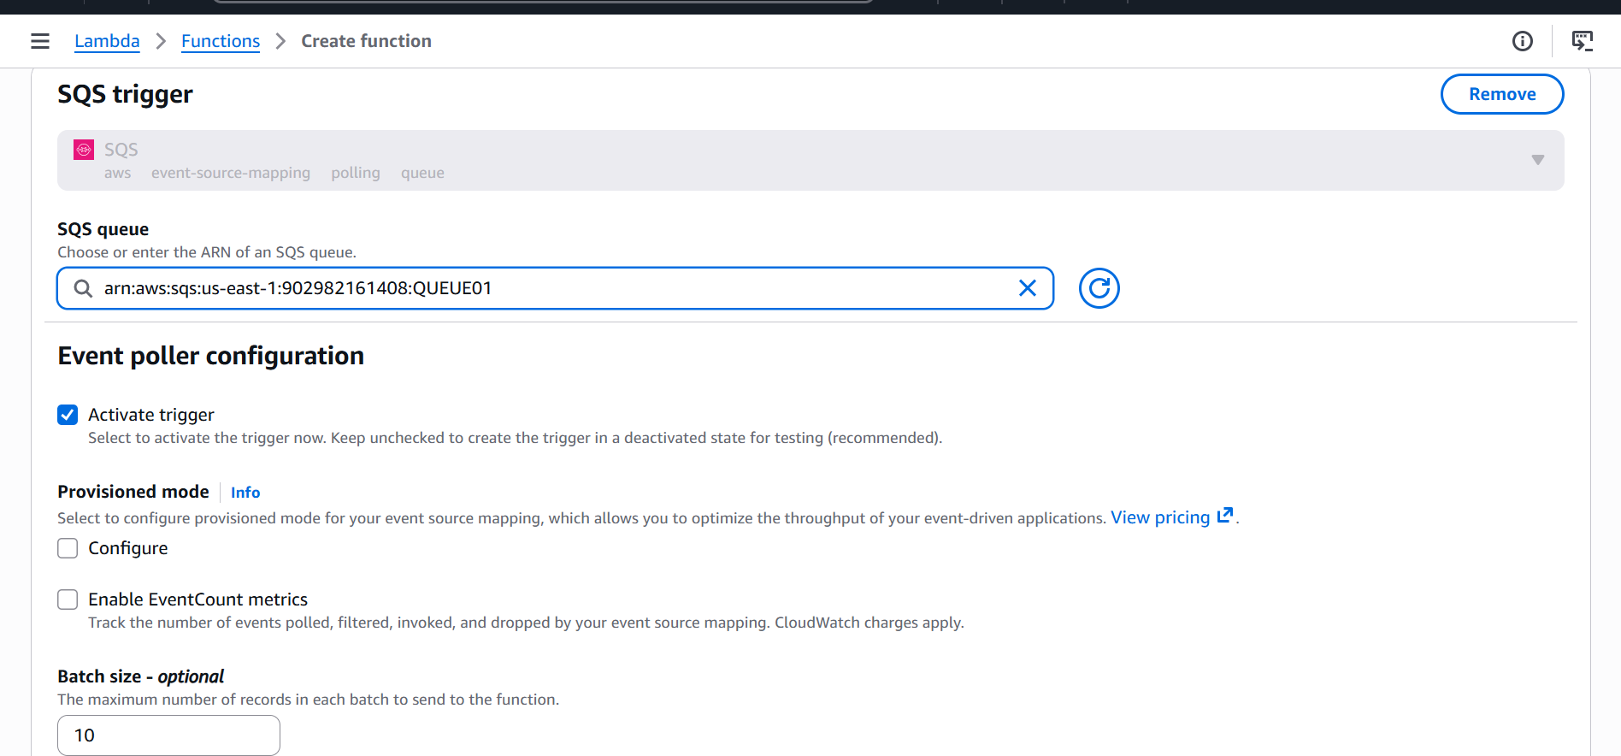

We need to give lambda iam permission to call from other services

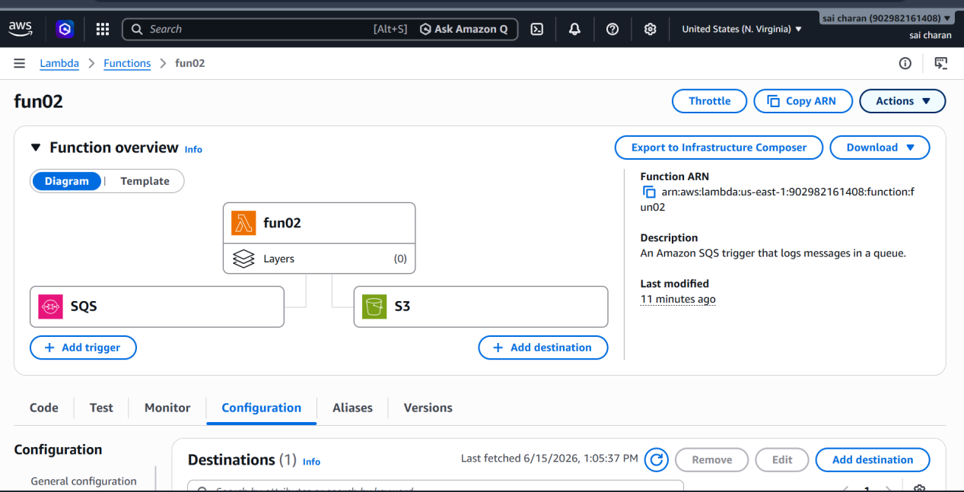
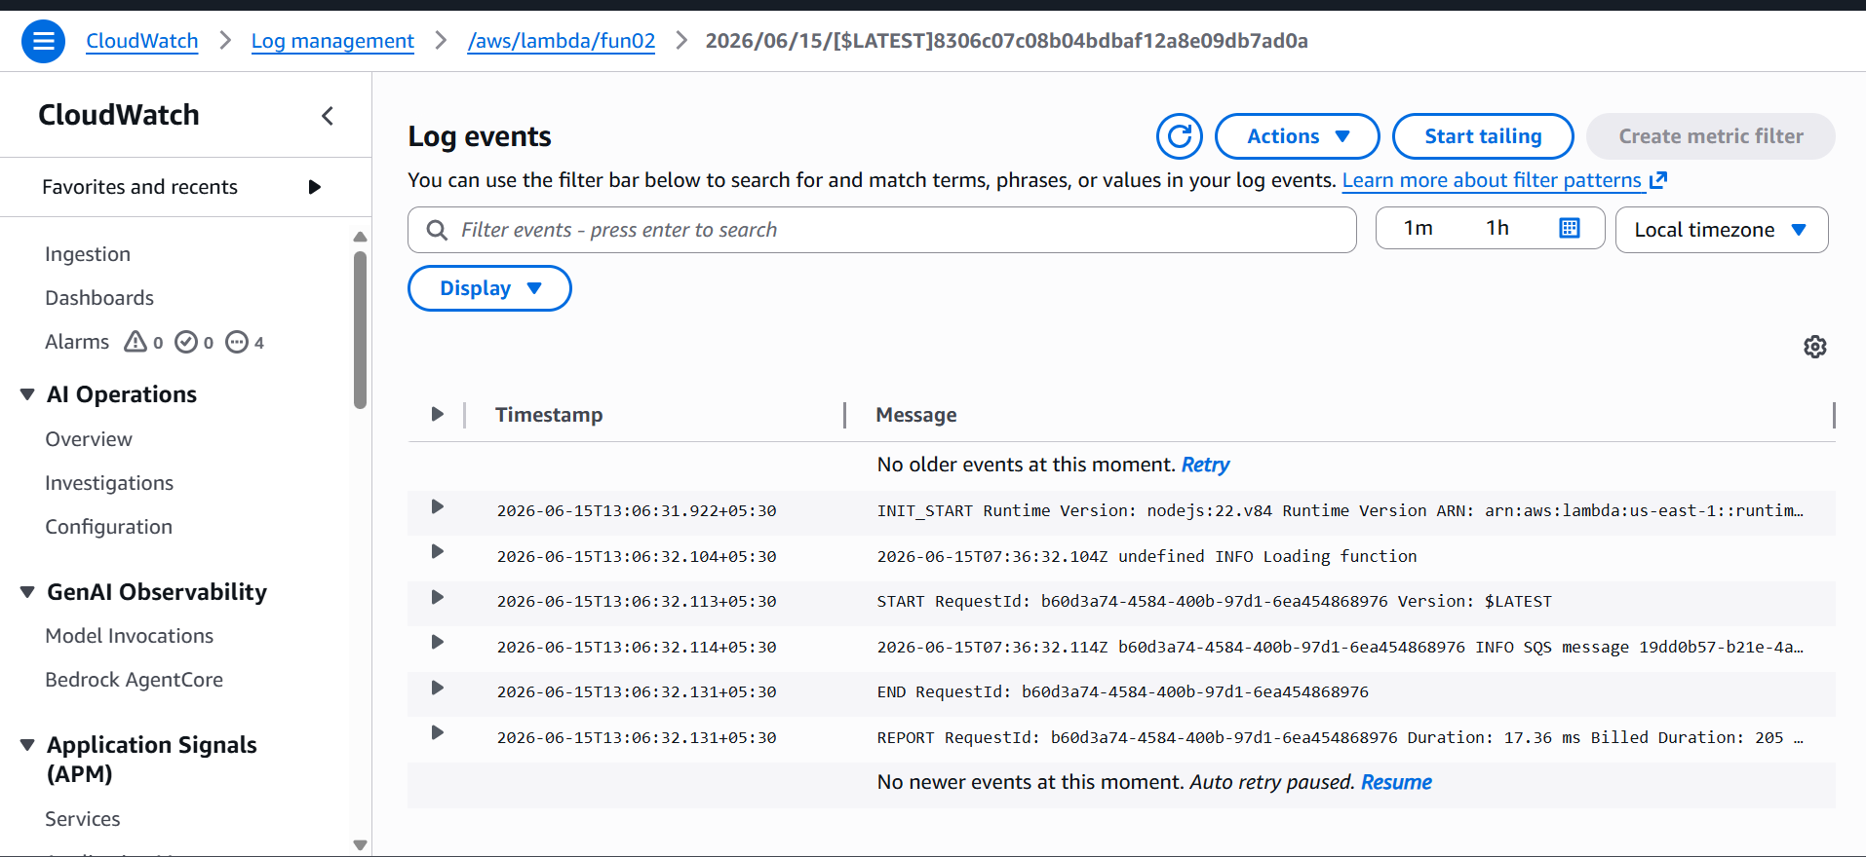

Now we can see the lambda handles the messages that were in queue SQS
We can also check this logs in cloudwatch logs

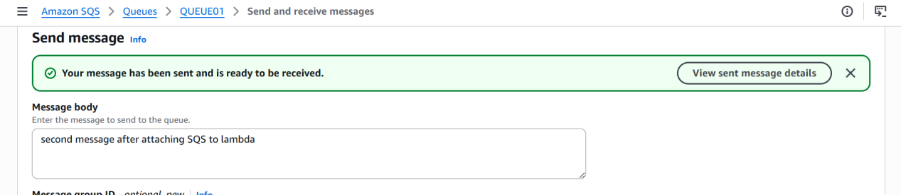

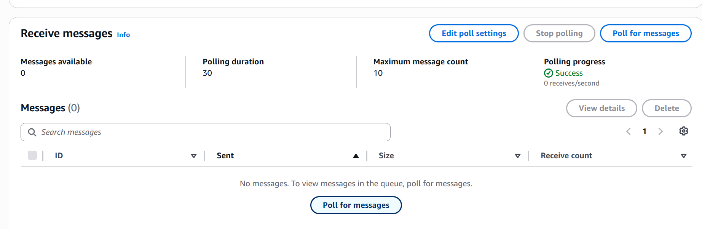

Now after attaching to lambda I cant see newly sent messages in poll messages because lambda gets the new messages first so sqs wont receive the message instead lambda gets it and performs necessary action

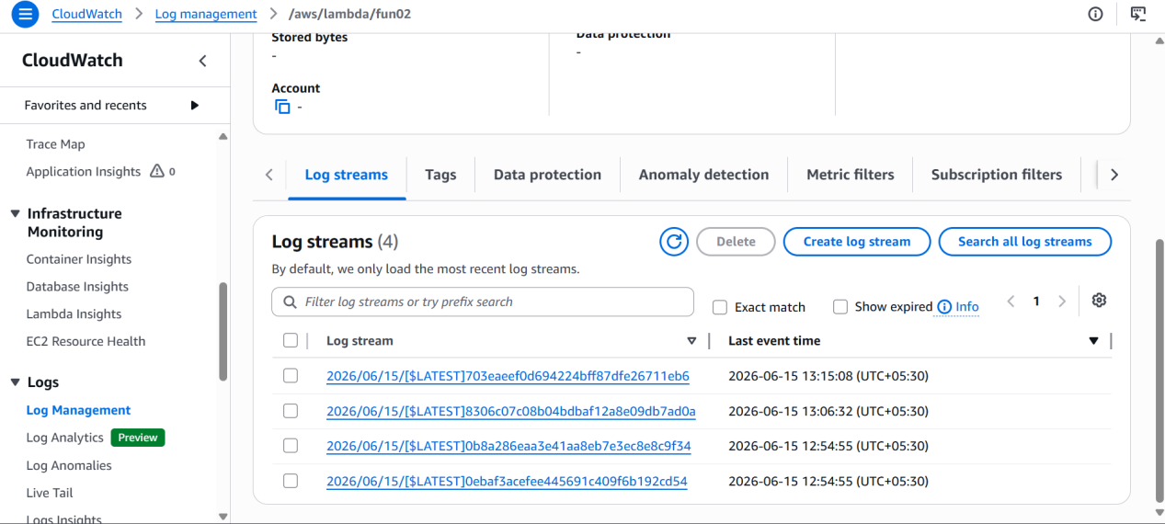

We can also see live tail for our sqs logs for any new message

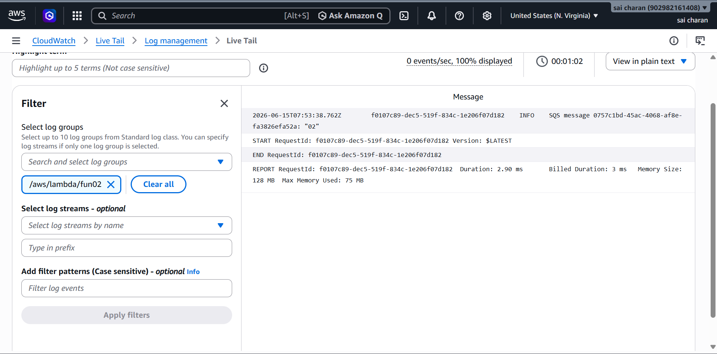

AMAZON MQ

Amazon MQ is a managed message broker service provided by AWS that simplifies setting up, operating, and maintaining open-source message brokers like Apache ActiveMQ and RabbitMQ

If we want to migrate our messaging platform to aws then the best option is MQ it doesn’t require code from scratch to migrate other messaging platform

Whenever we migrate from other messaging platform to aws the original message platform wont be down

Feature | Amazon MQ | Amazon SQS / SNS
Primary Intent | Migrating legacy systems seamlessly | Building brand-new cloud-native apps
Scaling Model | Fixed broker sizes; provisioned instances | Infinite, automated serverless scaling
Protocols | JMS, AMQP, MQTT, STOMP, WebSockets | Custom AWS SDK and HTTPS API endpoints
Pricing Model | Flat hourly broker instance cost + storage | Pay-per-request volume usage model

· Single-instance broker: Best for development, testing, or low-cost evaluation.
· Active/standby / Cluster deployment

First I have created a new security groups for every service

Ec2 , mq and rds toallow requests from only this sservices

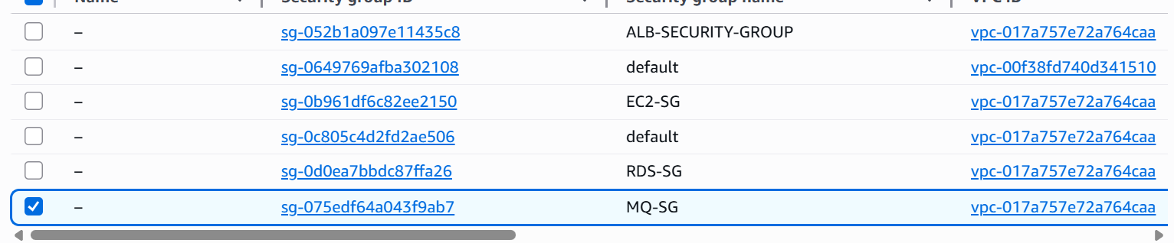

We have 2 types of deployment modes

· Single-instance broker: Best for development, testing, or low-cost evaluation.
· Active/standby / Cluster deployment

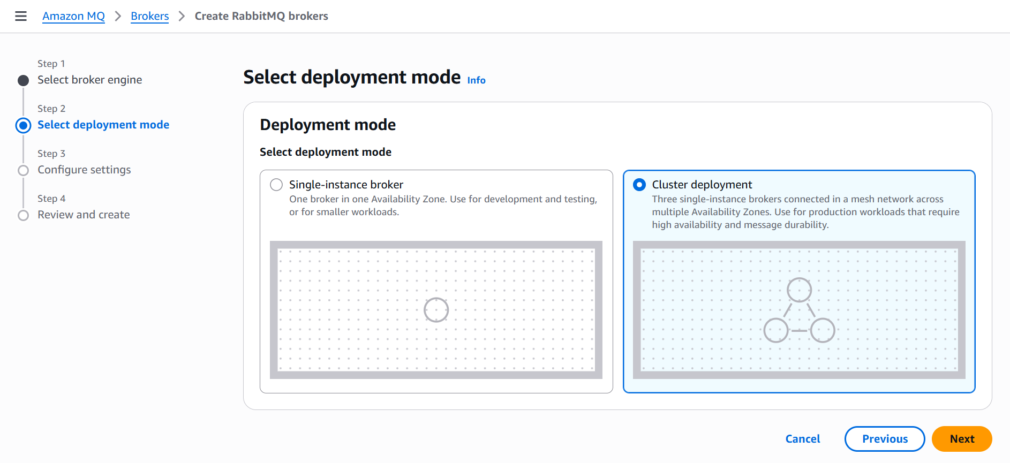

By using cluster deployment we can increase availability of the mq

I will be using single to test

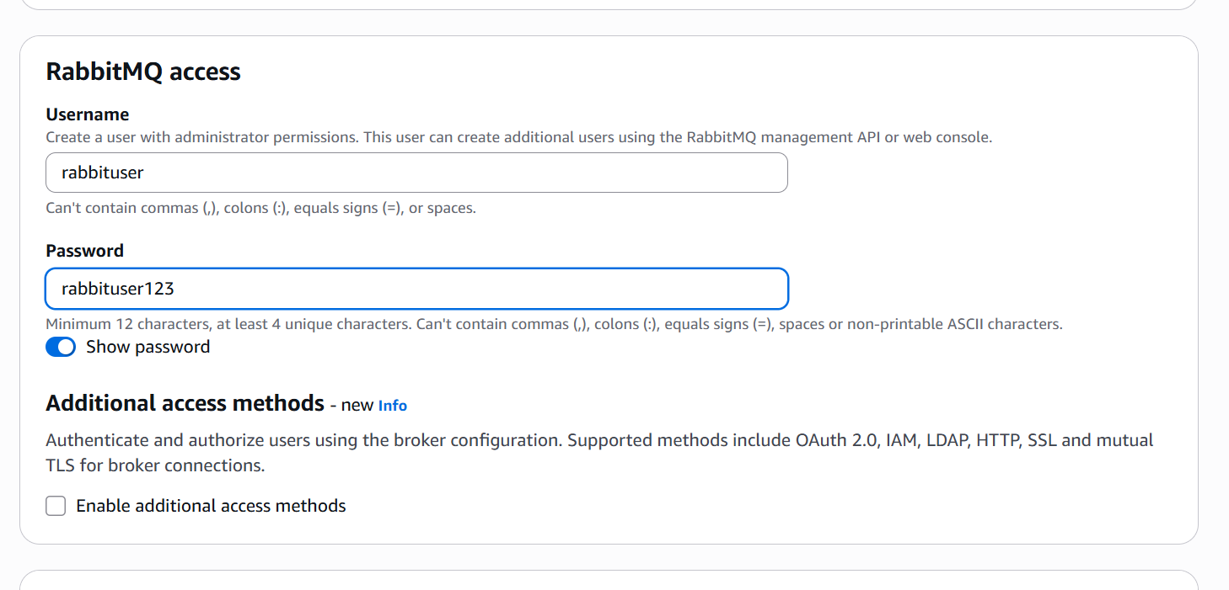

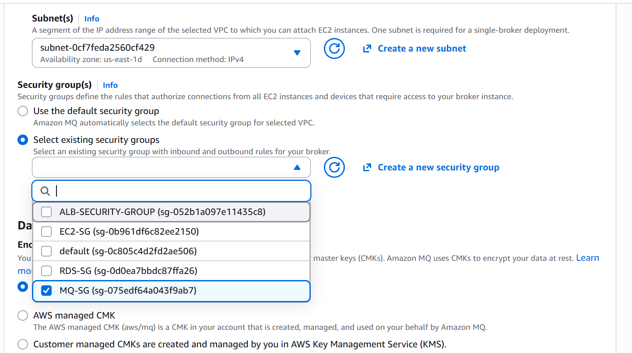

Created a new mq broker

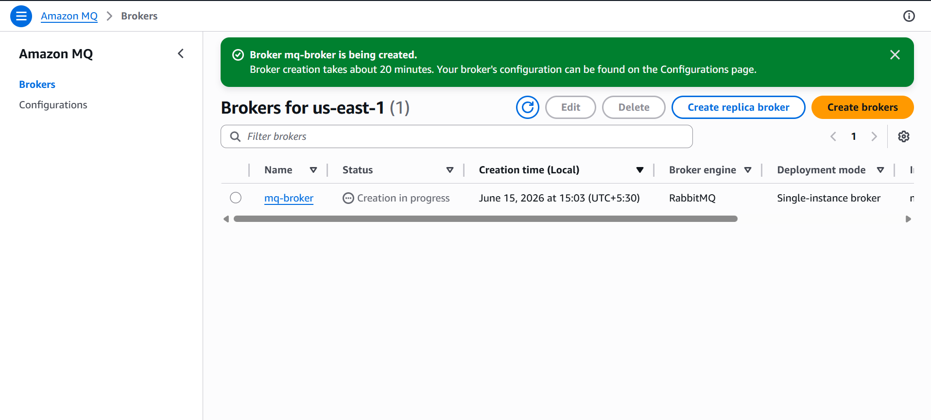
I will be creating a new instance and RDS

And will be attaching the mq broker for both

I below ss I have tested the connection b/w ec2 to mq
And ec2 to rds, both connections are reachable

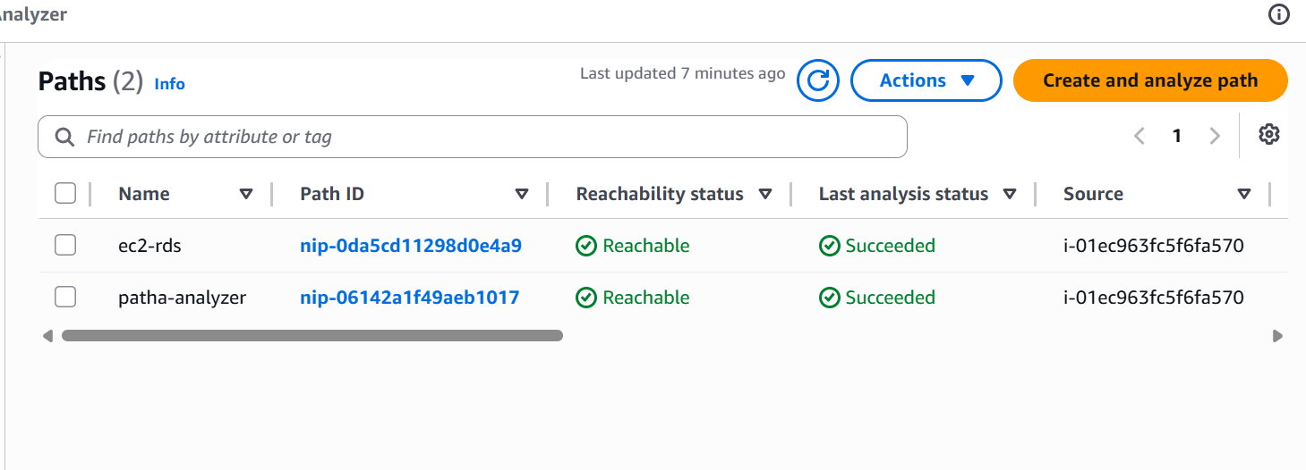

Now I will check into mq using sshg from terminal

Ssh -I keypair -L 8080:webpointurlofmq ec2-user@ip

Or use putty
Give instance ip to act as jump server for rabbitmq

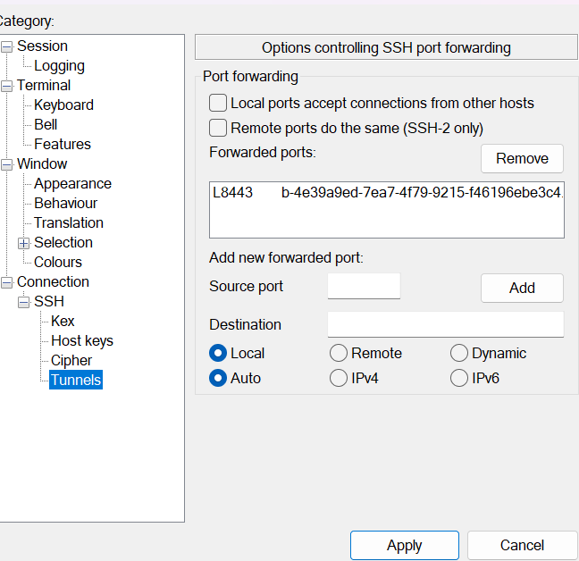

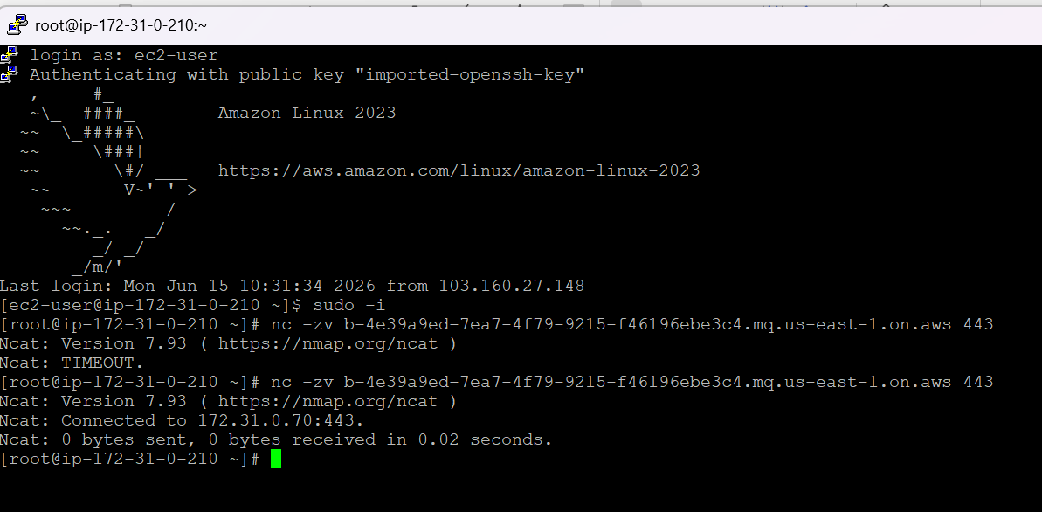
To connec
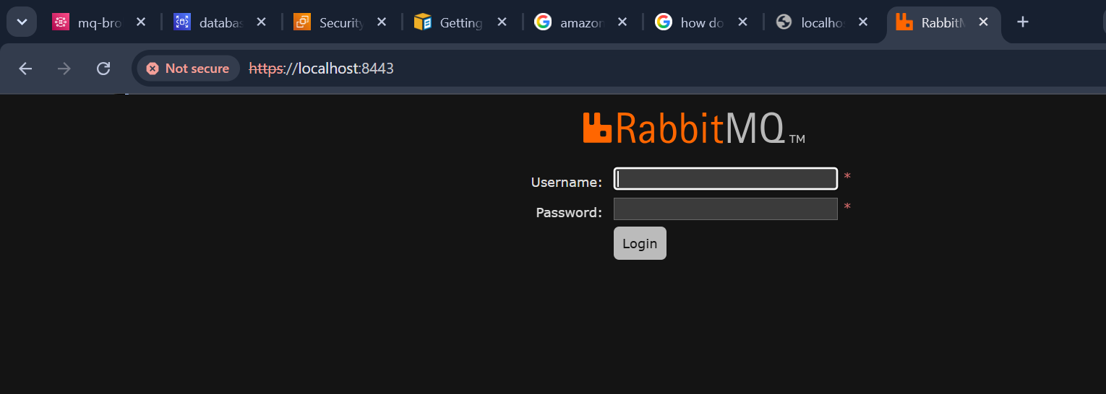

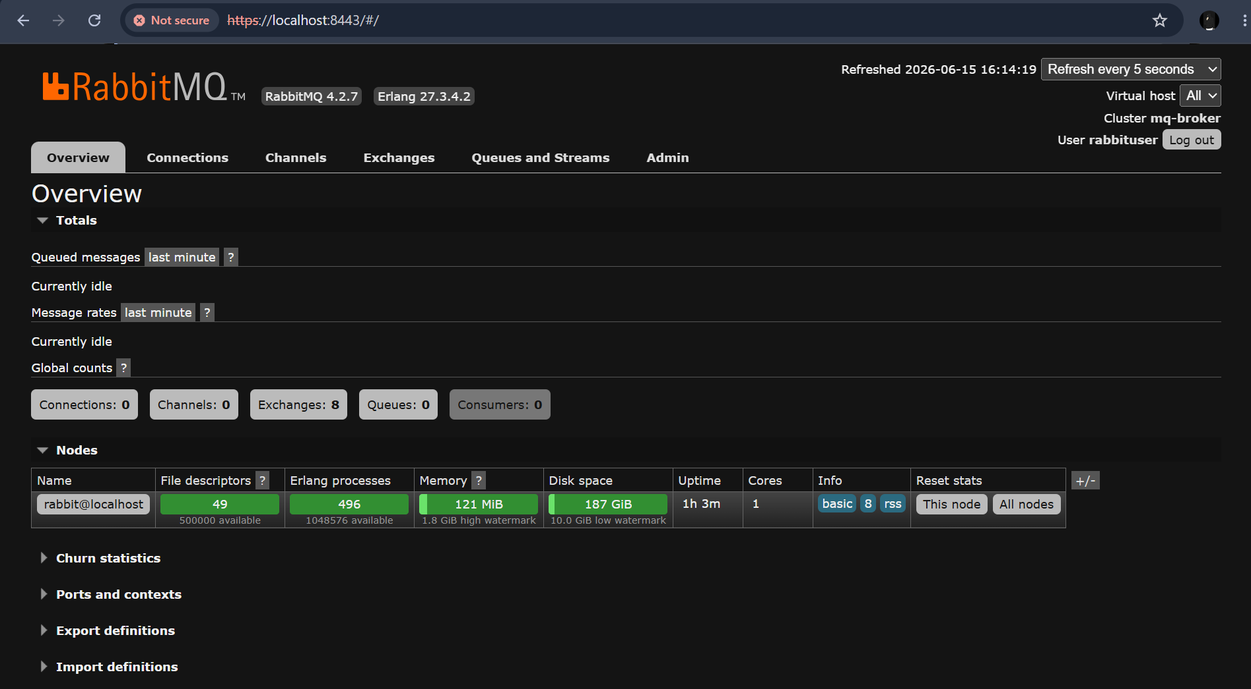
I have published a new message
And we can see count as 1

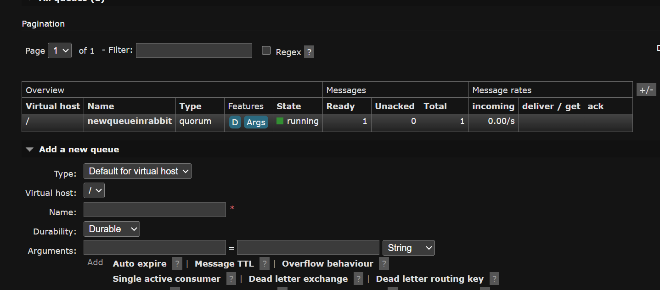

AWS SECRET MANAGER

AWS Secrets Manager is a fully managed service that helps you protect, rotate, and manage credentials needed to access your applications, services, and IT resources. It eliminates the need to hardcode sensitive information in your application code, configuration files, or environment variables

[ Application Service ]
│
▼
- Requests Secret via HTTPS API (GetSecretValue)
[ AWS Secrets Manager ]
│
▼
- Validates IAM permissions & Decrypts data using AWS KMS [ Decrypted Payload ]
│
▼
3. Delivers plain-text secret directly to Application Memory

Every single secret stored in Secrets Manager must be encrypted, and AWS KMS (Key Management Service) is the only encryption engine the service uses to do this

Choose secret type as other

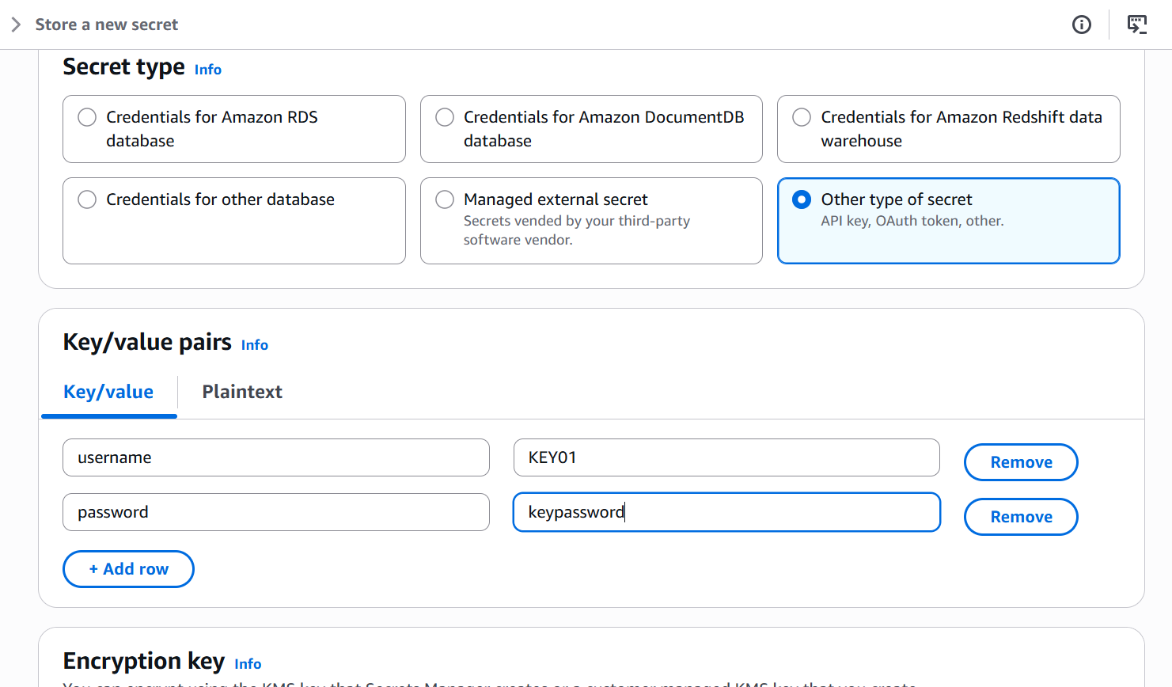

I am configuring secret manager for my rds database

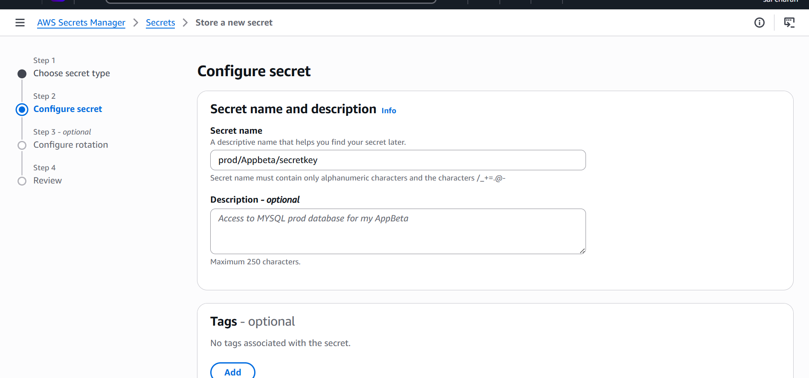

We can configure automatic rotation to change the passwords automatically or we can do it manually

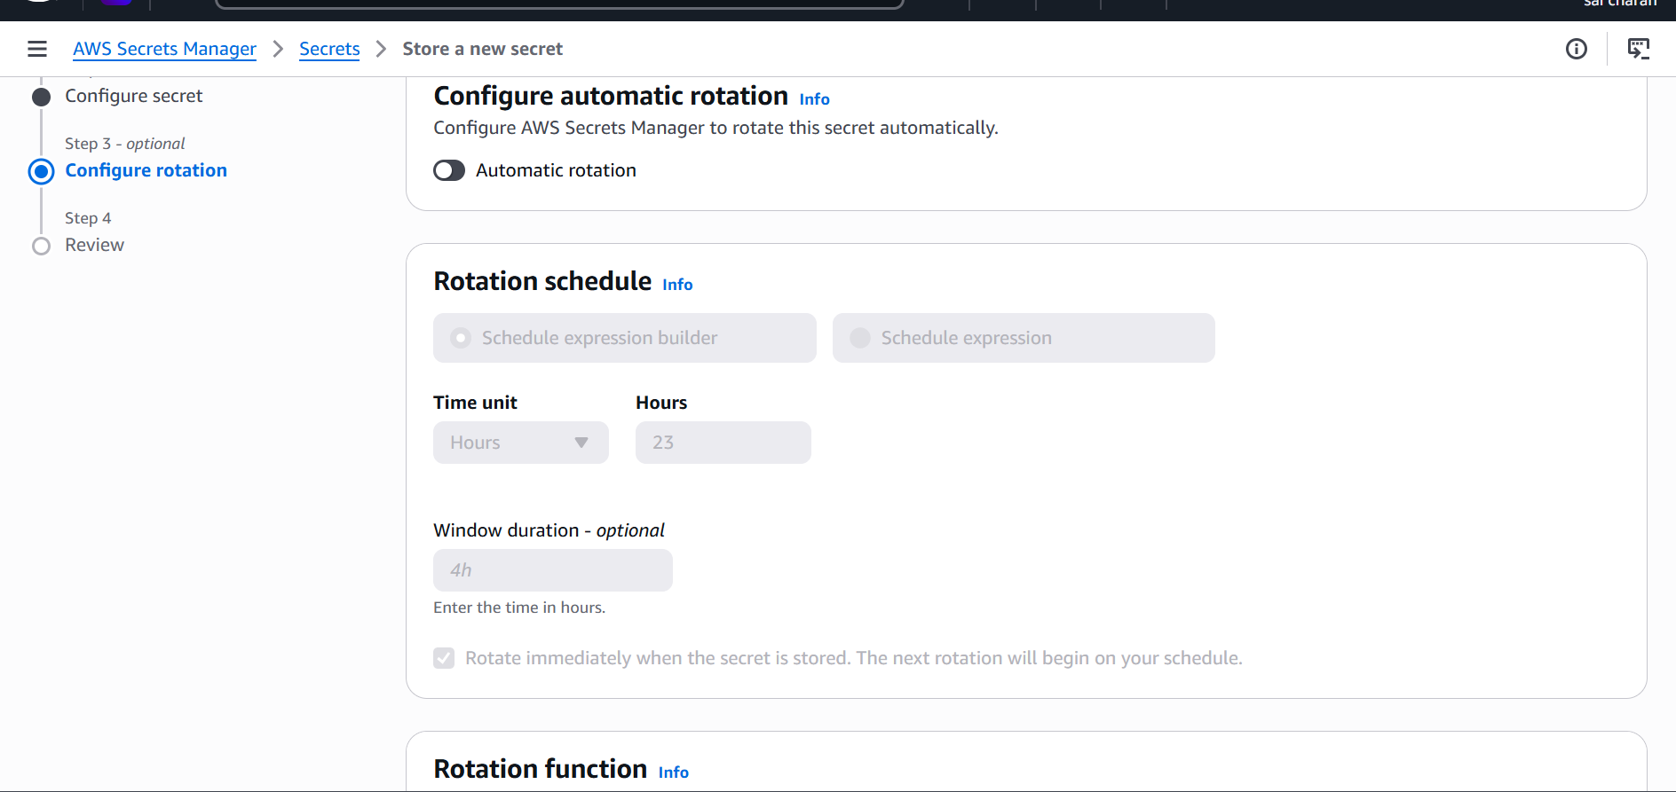

I have successfully created a new secret
For my RDS database

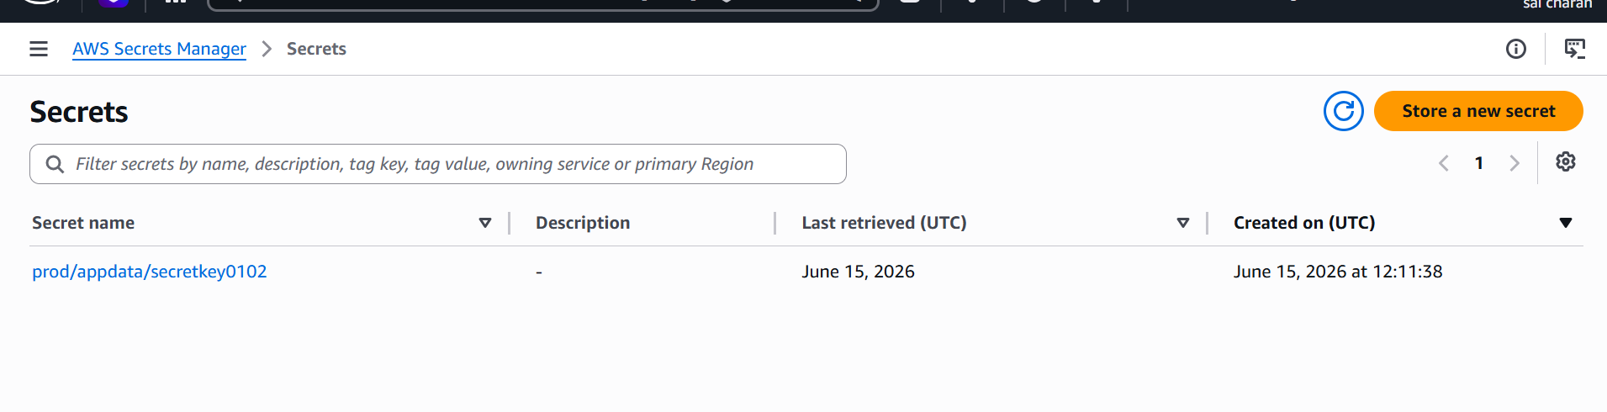

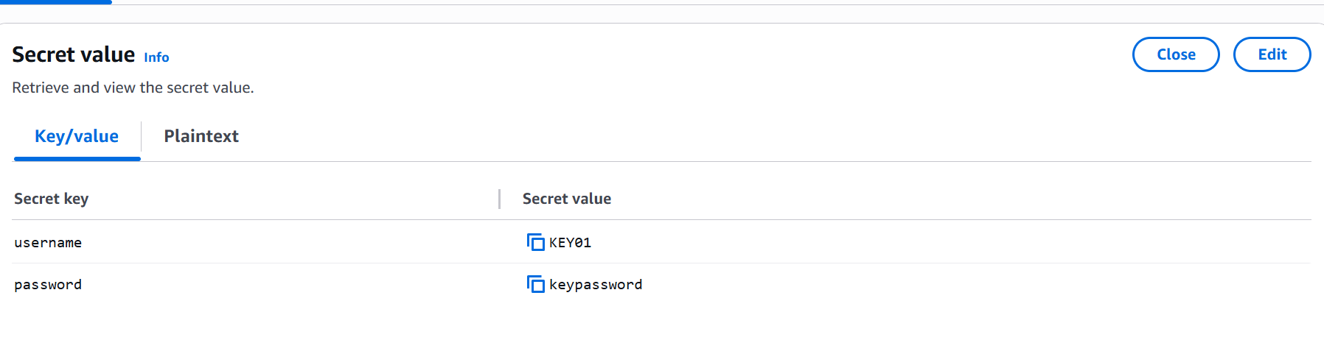

To use this secret key we need to link it to the iam policy

I am attaching this secret key to a instance

First I will be creating a new policy then add a new role select the ec2 then attach the policy in permissions tab

Then go to ec2 permissions and attach the newly created role in ec2 tab modify iam role

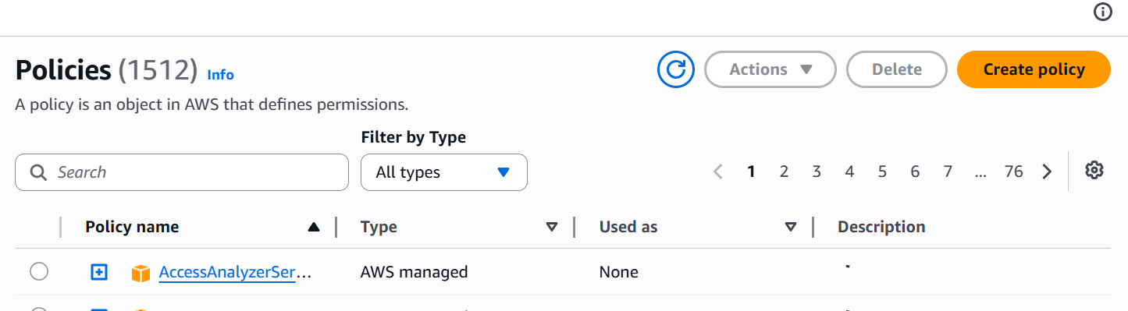

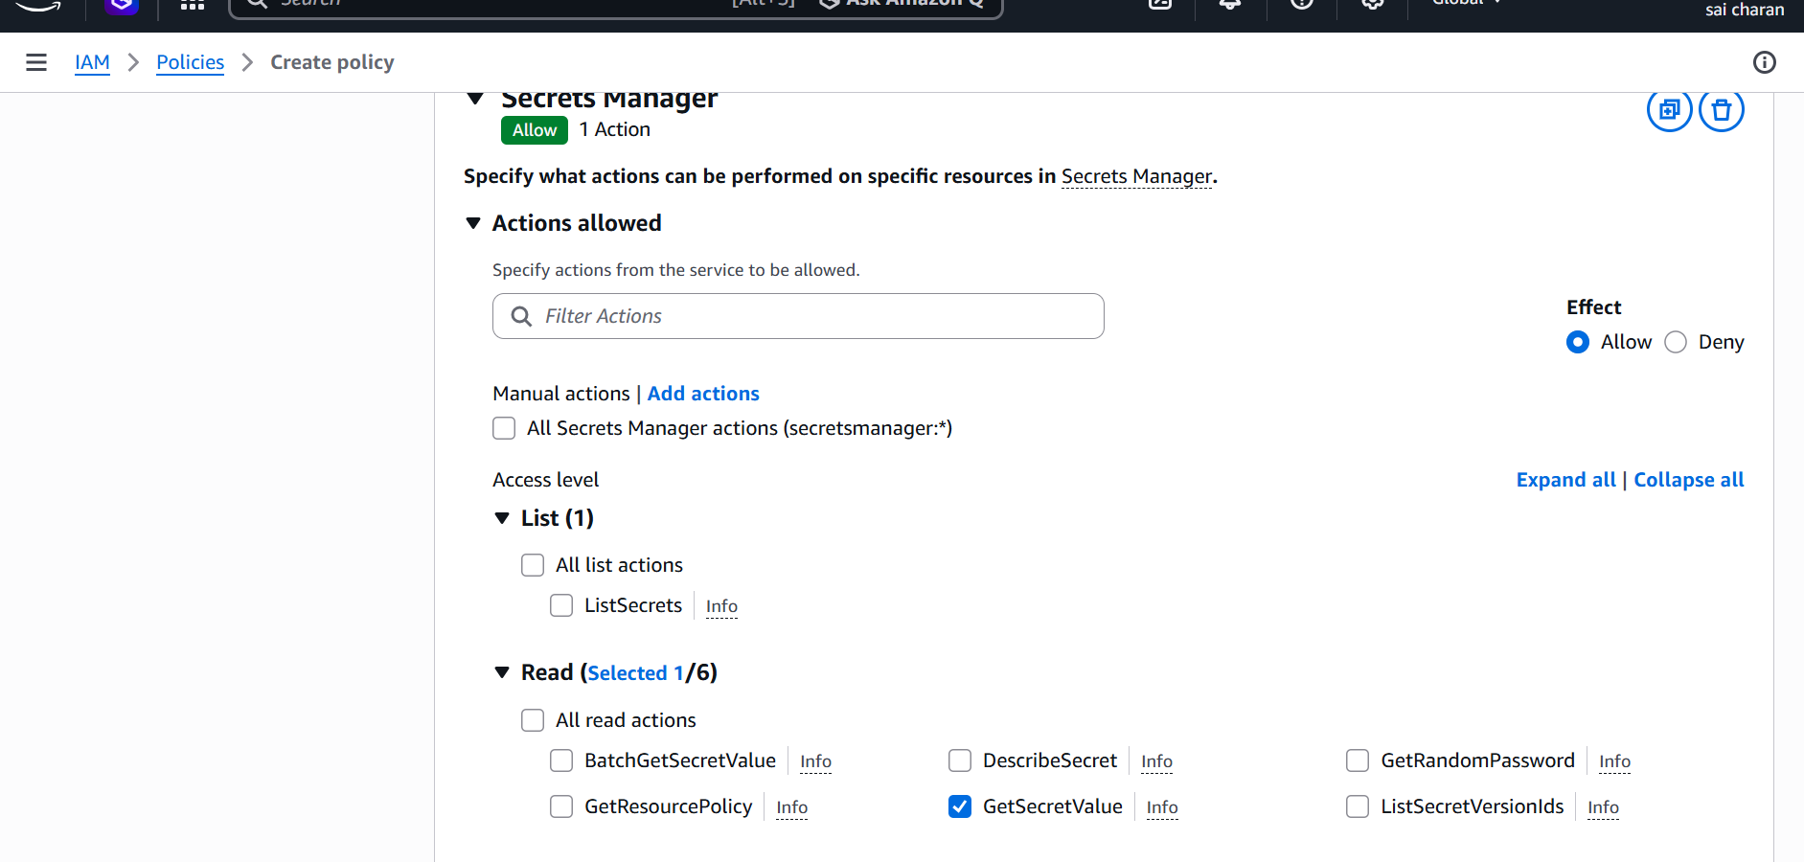

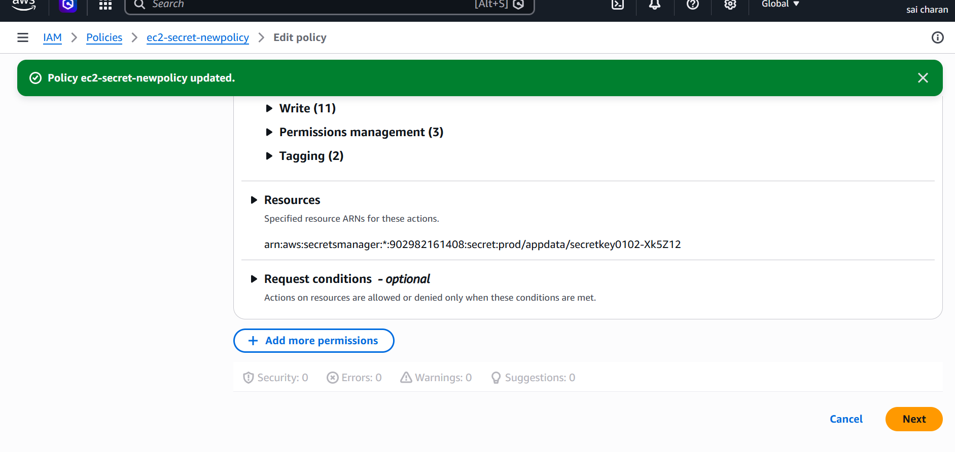

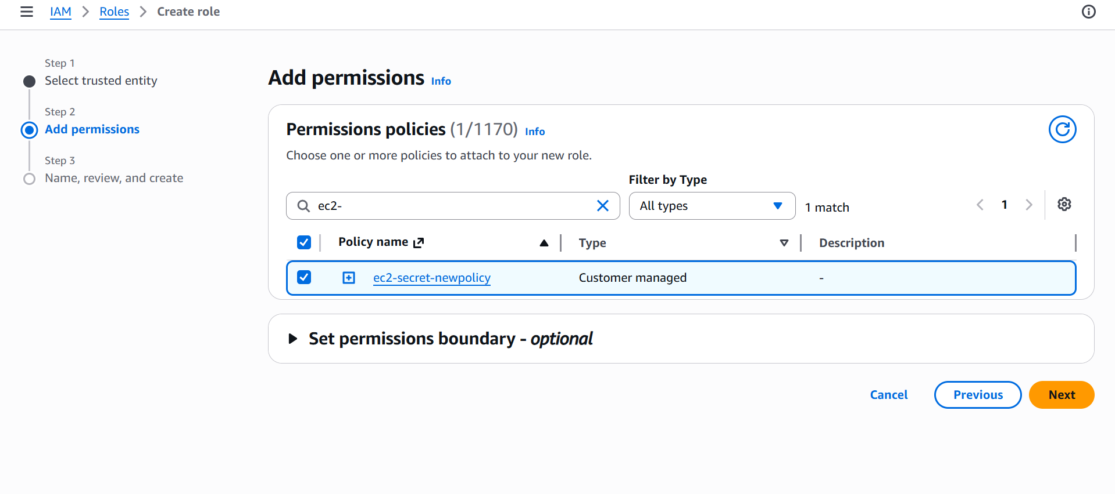

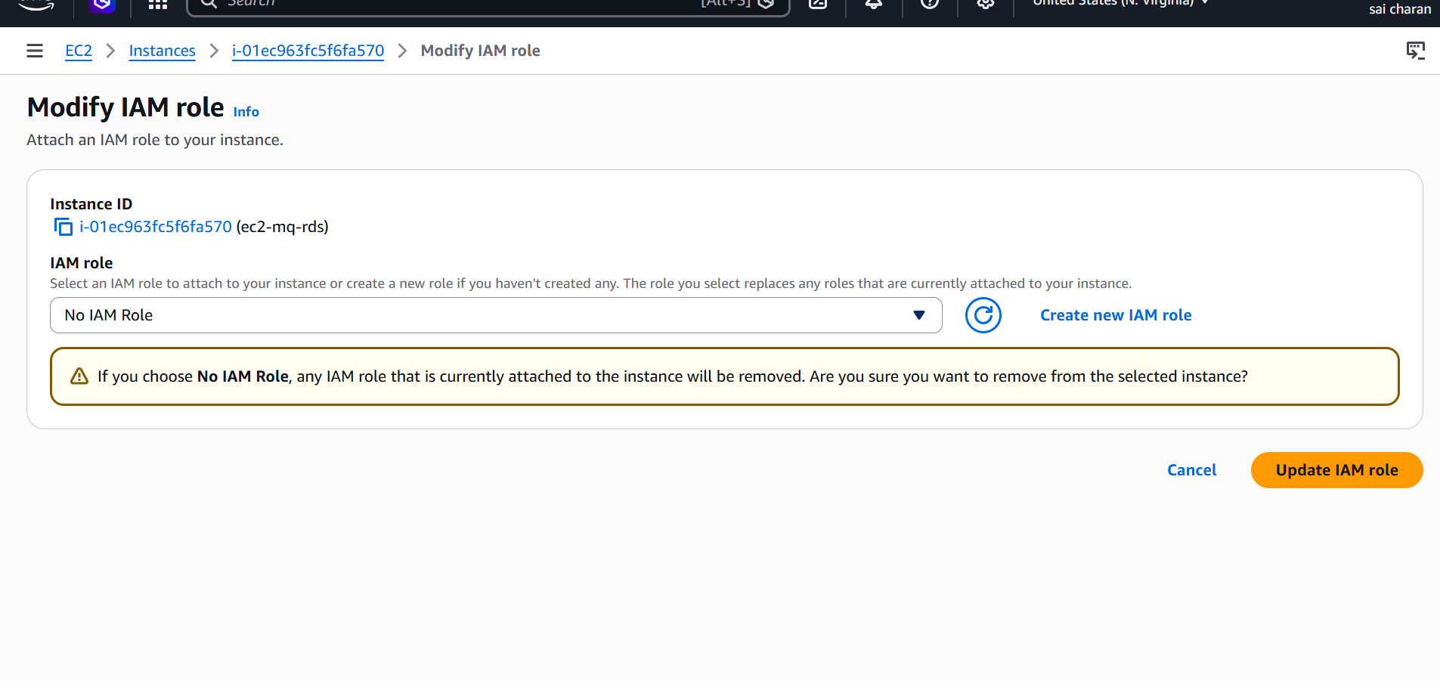

Now after attaching the policy the instance communicates b/w secrets manager without credentials

Now log into the instance

And use
Aws secretsmanager get-secret-value --secret-id secretname or ARN
Now we can see the secrets that the instance has



